***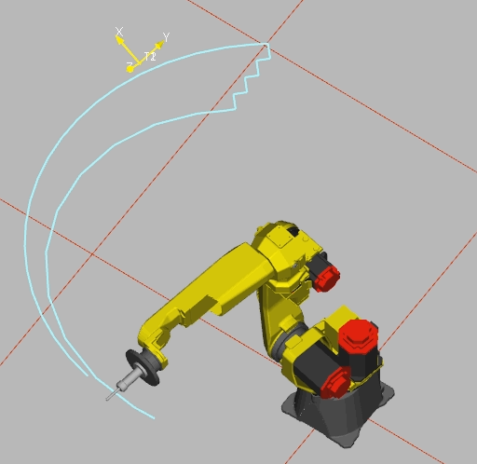*Programme *ESCALIER***

1. **R[1] = 0 (INITIALISATION)**
2. **PR[1] =LPOS (PR[1] =JPOS)**
3. **PR[1] = PR[1] – PR[1] (INITIALISATION)**
4. **LBL [1]**
5. **IF R[1] >= 3 , JMP LBL [2] (CONDITIONNEMENT)**
6. **L P[1] 4000 mm/s FINE OFFSET PR[1]**
7. **PR[1,2] = PR[1,2] – 50**
8. **L P[1] 4000 mm/s FINE OFFSET PR[1]**
9. **PR[1,1] = PR[1,1] + 50**
10. **R[1] = R[1] + 1 (COMPTEUR)**
11. **JMP LBL [1]**
12. **LBL [2] (FIN)**

**END**